**Chemistry 20 – Lesson 10**

**Double and triple bonds**

**/30**

**Part A**

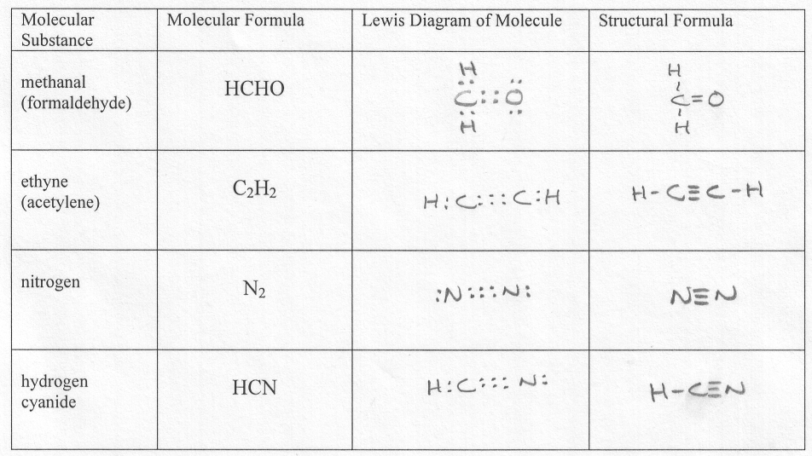

**Part B**

